EASO and Malta sign Operational and Technical Assistance Plan

* 27TH JUNE 2019

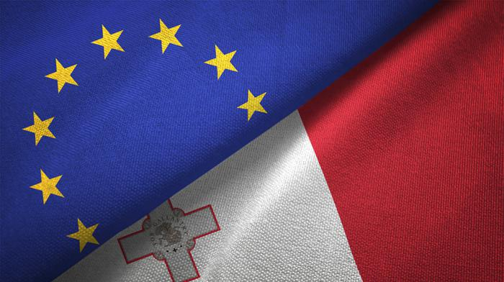

***The European Asylum Support Office (EASO) and the Maltese authorities have signed an***[***Operating Plan***](https://easo.europa.eu/sites/default/files/OP-Malta-2019.pdf)***for the deployment of Asylum Support Teams and the provision of technical and operational assistance to Malta up until 31 December 2019. The official document was signed by the Executive Director of EASO, Ms. Nina Gregori, and the Permanent Secretary of the Ministry for Home Affairs and National Security, Mr. Kevin Mahoney, on behalf of Malta.***

At the request of the Maltese authorities, the Operational and Technical Assistance Plan Support (Operating Plan) will see EASO provide tailor-made assistance, including by providing capacity building and backlog management support, technical expertise and quality control tools.

The Operating Plan is intended to ensure that persons in need of international protection in Malta have access to the international protection determination procedure, and, specifically, that the procedure at first instance is concluded as swiftly as possible.

Commenting on the signature of the Operating Plan, **Ms. Nina Gregori** stated: *"EASO’s core mandate is to support EU Member States in implementing the Common European Asylum System, including by rapidly deploying experts to provide assistance on-the-ground. Once again, we are delighted to be able to quickly and effectively provide tangible solidarity to a frontline Member State which has repeatedly proven to be an example of European solidarity itself.”*

Through its support, EASO aims to help alleviate the pressure on the Maltese asylum system. The activities under the Operating Plan will be closely coordinated with the Maltese authorities, in consultation with the European Commission, and in complementary continuation of the fruitful cooperation with the UNHCR.

The 2019 Operational and Technical Assistance Plan agreed to by EASO and Malta can be consulted [here](https://www.easo.europa.eu/sites/default/files/OP-Malta-2019.pdf).